**Arduino**

Arduino is an open-source platform used for building electronics projects. Arduino consists of both a physical programmable circuit board and a piece of software or Integrated Development Environment (IDE) that runs on your computer, used to write and upload computer code to the physical board.

The Arduino platform has become quite popular with people just starting out with electronics and for good reason. Unlike most previous programmable circuit boards, the Arduino does not need a separate piece of hardware to load new code onto the board, you can simply use a USB cable. Additionally, the Arduino IDE uses a simplified version of C++, making it easier to learn to program. Finally, Arduino provides a standard form factor that breaks out the functions of the micro-controller into a more accessible package.

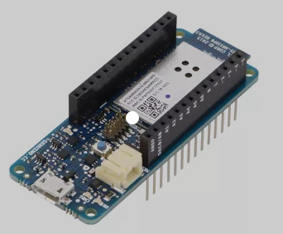

**Raspberry Pi**

Raspberry Pi boards are hugely popular single-board computers (SBCs) that are well suited to DIY IoT devices due to their small size and exhaustive capabilities. There are many different models of Raspberry Pi boards, with different combinations of ports and sensors.

**Main Advantages of using Raspberry Pi for IoT**

The Raspberry Pi is an exceptionally useful device due to its:

1. The list of languages using which it can connect to the internet is remarkable. Some widely used programming languages like Python, Java, and JavaScript are all compatible with the Raspberry Pi. It can also work as standalone server for smart home automation.
2. The RPi’s GPIO pins allow sensors to be directly attached, making it highly efficient in system deployment.
3. It is a cheap and full-featured device with a Linux OS.

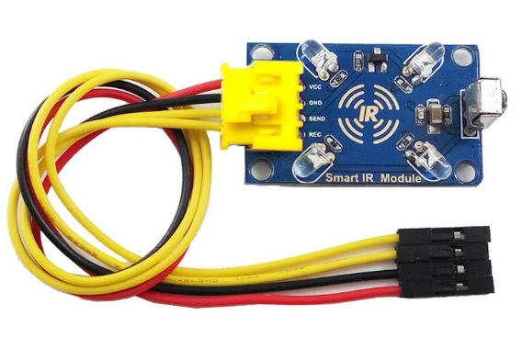

**Jumper wire**

A jumper wire is an electric wire that connects remote electric circuits used for printed circuit boards. By attaching a jumper wire on the circuit, it can be short-circuited and short-cut (jump) to the electric circuit.

Jumper wires typically come in three versions: male-to-male, male-to-female and female-to-female. The difference between each is in the end point of the wire. Male ends have a pin protruding and can plug into things, while female ends do not and are used to plug things into.

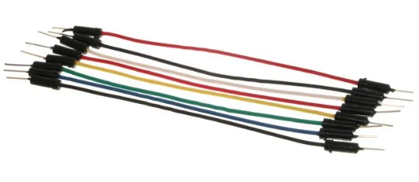

**Ultrasonic sensors**

**IoT ultrasonic sensors** are designed for non-contact detection of solid and liquid objects. These sensors are used for a wide variety of functions from monitoring the level of water in a tank to fluid identification/concentration, to detecting object proximity. Ultrasonic sensors have become indispensable for [IoT delivery](https://www.seebo.com/iot-delivery/) and are widely used for building smart, connected products. Understand more about the different types of sensors, how they work, and their applications for everything from smart car reversal systems to smart waste bins.

**Advantages of Ultrasonic Sensors**

* Ultrasonic sensors produce ultrasonic frequencies that humans cannot hear, making them ideal for use in environments that require low noise levels.
* An ultrasonic sensor response is not dependent upon the surface color or optical reflectivity of the object e.g., a glass plate or a shiny aluminum plate.
* These sensors don’t require much electricity, are simple in design, and are relatively inexpensive.
* Ultrasonic sensors with digital (On/Off) outputs have excellent repeat sensing accuracy. It is possible to ignore immediate background objects, even at long sensing distances because switching hysteresis  (the physical property value lags behind changes in the causation effect) is relatively low.

**Disadvantages of Ultrasonic Sensors**

* Ultrasonic sensors have a minimum sensing distance.
* Changes in the environment, such as temperature, pressure, humidity, air turbulence, and airborne particles affect ultrasonic responses.
* Targets with low density, such as foam and cloth, tend to absorb sound energy and these materials may be difficult to sense at long ranges.
* Ultrasonic sensors must be in the direct line of sight of the surface of the object in order to receive an adequate sound echo. Additionally, the reliability of these sensors requires a minimum object surface area.
* Smooth surfaces reflect sound waves more efficiently than rough surfaces.

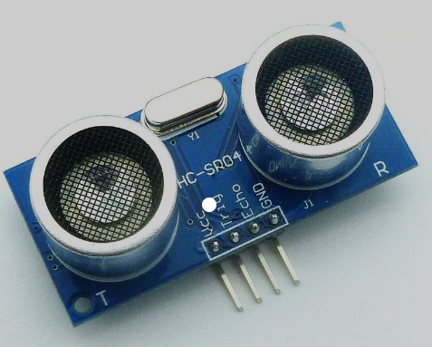

**Temperature sensors**

A temperature sensor is an electronic device that measures the temperature of its environment and converts the input data into electronic data to record, monitor, or signal temperature changes.

**Breadboard**

The breadboard is a white rectangular board with small embedded holes to insert electronic components. It is commonly used in electronics projects. We can also say that breadboard is a prototype that acts as a construction base of electronics.

A breadboard is derived from two words bread and board. The word breadboard was initially used to slice the bread pieces. But, it was further named as a breadboard for its use in electronics around the 1970s. Hence, the term breadboard refers to these boards only and provides a quick electrical connection.

A breadboard is also categorized as a **Solderless board**. It means that the component does not require any soldering to fit into the board. Thus, we can say that breadboard can be reused. We can easily fit the components by plugging their end terminal into the board. Hence, a breadboard is often called a **plugboard**.

**PIR sensor**

PIR sensor is widely used as motion sensor to detect the human or animal activity in a particular area. All objects emits heat energy in the form of radiation which can be visible when the wave length reaches in the visible spectrum. But there are certain ranges of radiations which could not be recognised with human eye but can be sensed with certain sensors.

Infrared radiation emitting from human or animal body can’t be sensed by our naked eye but can be detected by pyroelectric sensors. The sensor which detects infrared radiation emitting from other objects are called passive infrared sensors. They are called “passive” since the sensor itself doesn’t emit any IR radiation but passively sense the radiation emitting from the source. . It is now an unavoidable entity in [building automation](https://www.wemakeiot.com/building-automation/) systems

**Buzzer**

A buzzer or beeper is an audio signaling device, which may be mechanical, electromechanical, or piezoelectric (piezo for short). Typical uses of buzzers and beepers include alarm devices, timers,train and confirmation of user input such as a mouse click or keystroke.

**Register**

By registering each device in your IoT ecosystem it will get its own SSL or TLS security standards & a personal key – the unique identifier of the device. Both of these are mandatory for verified access, authentication on a network, & device encryption.

**LED**

LEDs (light-emitting diodes) are small, bright, power-efficient lights commonly used in electronic products. An LED light is a polarized part, meaning it has to be connected to a circuit in a certain way to work properly.

The major uses of LED (Light Emitting Diodes) are to illuminate objects and even places. Its application is everywhere due to its compact size, low consumption of energy, extended lifetime, and flexibility in terms of use in various applications. Applications and Uses of LEDs can be seen in: TV Backlighting.

**Servo motor**

Servo motors are a class of motors where you can tell the motor, what position it should move to or what speed it should move, and it's internal mechanism uses some form of feedback to ensure that the required position or velocity is achieved.

Servo motors or “servos”, as they are known, are electronic devices and rotary or linear actuators that rotate and push parts of a machine with precision. Servos are mainly used on angular or linear position and for specific velocity, and acceleration.

**SOIL MOISTURE SENSOR:**

The soil moisture sensor is one [kind of sensor](https://www.elprocus.com/accelerometer-sensor-working-and-applications/) used to gauge the volumetric content of water within the soil. As the straight gravimetric dimension of soil moisture needs eliminating, drying, as well as sample weighting. These sensors measure the volumetric water content not directly with the help of some other rules of soil like dielectric constant, electrical resistance, otherwise interaction with neutrons, and replacement of the moisture content.

Soil moisture sensors **measure the water content in the soil and can be used to estimate the amount of stored water in the soil horizon**. Soil moisture sensors do not measure water in the soil directly. Instead, they measure changes in some other soil property that is related to water content in a predictable way.

The most common types of soil moisture sensors include **gypsum blocks, tension meters, capacitance, volumetric, and neutron probes**. These sensors either measure soil tension when placed in the soil or measure volumetric water content.

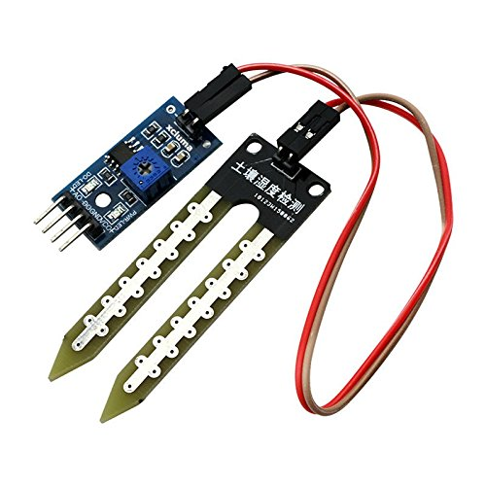

**RELAY SWITCHES:**

A relay is an **electrically operated switch**. It consists of a set of input terminals for a single or multiple control signals, and a set of operating contact terminals. The switch may have any number of contacts in multiple contact forms, such as make contacts, break contacts, or combinations thereof.

Relays are **switches that open and close circuits electromechanically or electronically**. Relays control one electrical circuit by opening and closing contacts in another circuit.

